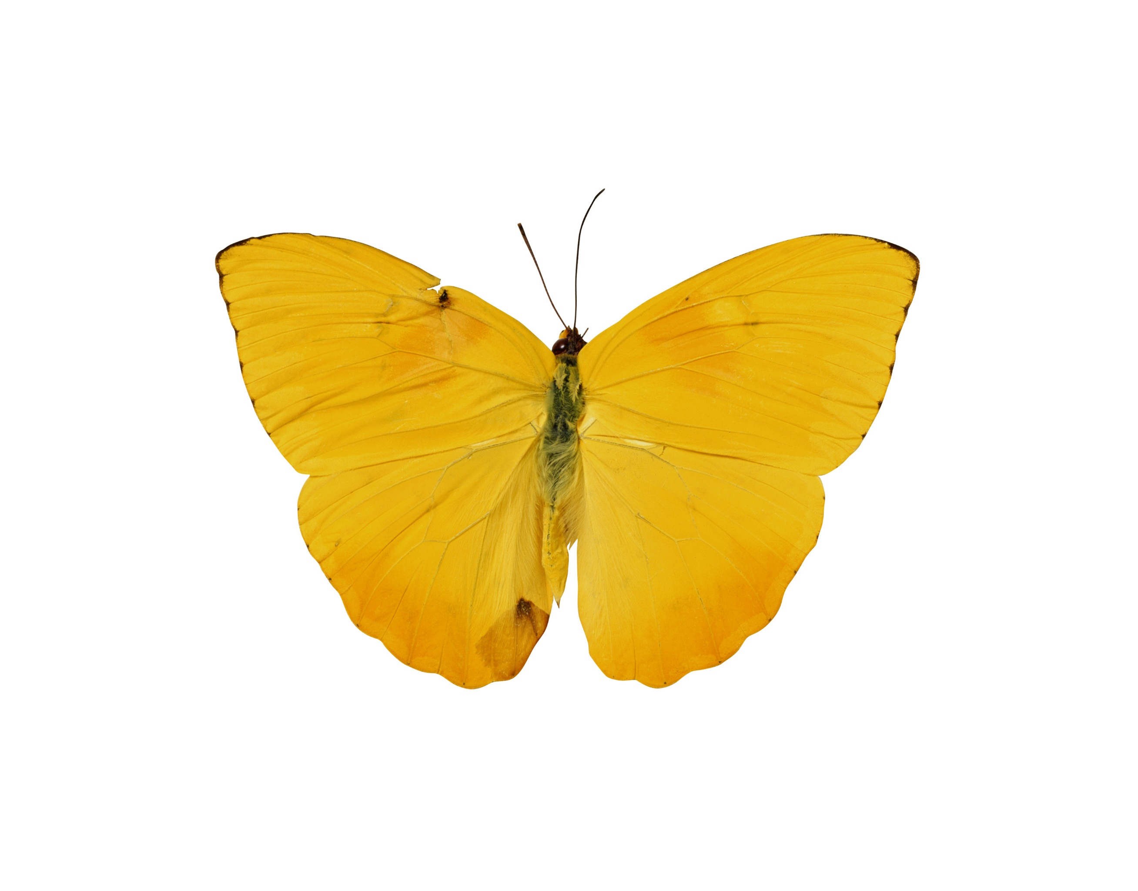

Aashish Mahajan- 120766 2725  
Software Design  
Prof Caliss

Design Pattern

## uml Diagram for the assignment

Please find the attached inline picture for brief idea about the interaction taking place in the project.

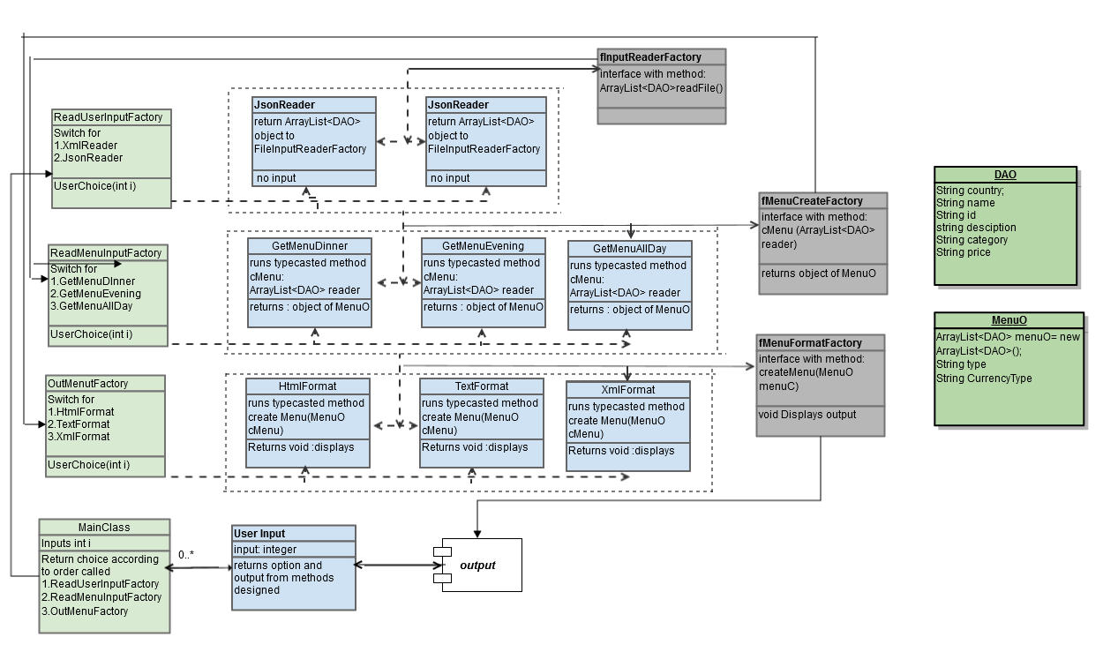

Along with this is I have made a uml – class diagram in the project itself so that it could be referred while working on the  
project. Please find that file in the .war file. Under the folder java resource ----> src -🡪com.mkyong.seo --🡪uml.cls

### Project setup : read me

To work and setup the project , one needs a eclipse indigo j2ee version. Once downloaded and setup, one need to make it sure that java is installed and path is set in environment variables.

1. Open eclipse.
2. Select import and type war , it would give a import folder for .war extension file.
3. Setup the import and build path with tom cat library.
4. Add the FoodItemData.json and FoodItemData.xml to the desktop.
5. Some additional libraries that would be required are :  
   a. json.simple1.1  
   b. com.springsource.org.codehaus.jackson.mapper-1.4.2  
   c. jackson-core-asl-1.5.0
6. Build path with tomcat 7.0 and link with the external jars in tomcat library.
7. The output files for TextFormat and XmlFormat are stored in drive D:// with name test. Extension
8. Just run as an java application and inputs from user would be required in the console box.

### Process followed while designing

While working on the project firstly I designed individual method to make the system working and make the cross functionality work in the single main class.   
After the functionality was working, started implementing the factory method, clubbing the same method name and functionality in factory interface and making the classes implement the method of interface and overriding the method of interface under the respective method classes.

Once going through code one could see that the naming convention followed makes it easy to follow through the structure. The class diagram in the src files makes it more transparent to see the actual implementation of the software pattern design the assignment asked us implement.